“Sure. In our previous project, we have a REST Assured API automation framework using Java, Maven, and TestNG. The framework is data-driven, where all inputs like payloads, endpoints, and expected results come from Excel and JSON files.
We were used the framework with a service-layer structure, having reusable request builders, POJO classes for serialization/deserialization, and a Base class for common setup like base URI, authentication tokens, headers, and logging.
We automated all major API flows including GET, POST, PUT, PATCH, and DELETE, and added validations for status codes, response body, JSON schema, and error conditions.
The suite runs in Jenkins for every deployment, and we publish Allure/Extent reports to the team with detailed logs.

🚀 REST Assured API Testing Project Explanation (Data-Driven + Maven Framework)

2️⃣ Tools & Technologies Used
- REST Assured → For API automation
- Java → Programming language
- Maven → Dependency & build management
- TestNG → Test execution, assertions, reporting
- DDB (Data-Driven) → External data source (Excel/JSON)
- Apache POI / Jackson → For reading Excel/JSON test data
- Extent Reports / Allure → For reporting (optional)
- Git / Jenkins → CI/CD integration

3️⃣ Framework Architecture (How you explain it)
“My framework is structured using the Page Object Model-like approach for APIs, called Service Layer Design.”
• base/ → Common setup for all tests (base URL, headers, specs).
• config/ → Environment and endpoints (dev/qa/prod URLs and API paths).
• models/ → POJO classes for request and response bodies (for JSON mapping).
• clients/ → One class per API area (e.g., UserClient) with methods like createUser(), getUser().
• builders/ → Test data builders to quickly create valid/invalid payloads.
• utils/ → Reusable helpers (request/response specs, token manager, JSON helpers).
• tests/ → Actual TestNG tests (clean: arrange → act → assert).
• schemas/ → JSON schema files for contract checks.
• resources/env/ → qa.properties, dev.properties for base URL and secrets.

📁 Project Structure
src/test/java
├── base
│ └── BaseTest.java
├── utils
│ ├── ExcelUtils.java
│ └── JsonUtils.java
├── requestBuilders
│ └── UserRequestBuilder.java
├── testData
│ └── testData.xlsx
├── tests
│ └── UserAPITest.java
pom.xml

4️⃣ Key Features of the Framework
✔ Data-Driven Testing (DDB)
- Test data (URL, headers, payloads, expected results) is read from:
  - Excel
  - JSON
- This enables running the same test with multiple datasets.
Example:
- Create User API → multiple users from Excel
- Validate response code/response body dynamically

✔ Request Builder Pattern
Used to keep payload logic reusable.
Example:
Java
public class UserRequestBuilder {
public JSONObject createUserPayload(String name, String job) {
JSONObject obj = new JSONObject();
obj.put("name", name);
obj.put("job", job);
return obj;
}
}
Show more lines

✔ TestNG for Test Execution
- Parallel execution
- DataProviders for DDB
- Assertions for validation
Example:
Java
@DataProvider(name = "userData")
public Object[][] getData() {
return ExcelUtils.readExcel("CreateUser");
}
✔ Validation
You validate:
- Status code
- Response time
- JSON Schema
- Response body fields
Example:
Java
given()
.body(payload)
.when()
.post("/users")
.then()
.statusCode(201)
.body("name", equalTo(expectedName))
.log().all();
Show more lines

✔ Maven Integration
- All dependencies maintained in pom.xml Example:
✔ CI/CD Integration
- Framework integrated with Jenkins
- After every commit, tests run automatically
- Reports published in Jenkins dashboard

5️⃣ What Types of API Tests You Performed
Explain these clearly:
✔ CRUD Operations
- POST → Create
- GET → Retrieve
- PUT/PATCH → Update
- DELETE → Remove
✔ Functional Testing
- Validations of fields
- Checking business rules
✔ Negative Testing
- Invalid payload
- Missing headers
- Wrong HTTP method
✔ Authentication Testing
• Basic Auth → Sends username + password (usually Base64-encoded) on every request.
• OAuth 2.0 → Uses authorization framework where the client gets a token after user approval.
• Bearer Token → Sends a token string in the header (Authorization: Bearer <token>) to access protected APIs.
✔ Schema Validation
Using JSON schema validator.

8. Challenges & Solutions (Strong talking point)
Challenge 1: Dynamic Payload Handling
Solution:
Used POJO + Builder pattern + JSON templates.

Challenge 2: Authentication Token Expiration
Solution:
Implemented:
- Auto token regeneration
- Token caching
- Token lifecycle management

Challenge 3: Multiple Environment Support
Solution:
Added a configuration manager with:
config-qa.properties
config-stg.properties
config-uat.properties

Challenge 4: Data Parameterization
Solution:
Custom Excel reader + DataProvider.
Path and Query parameters :
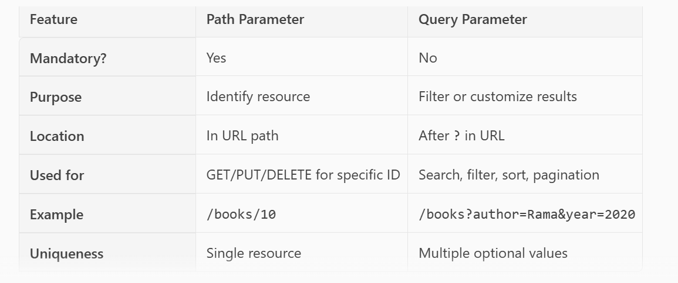
• Serialization: Converting a Java object (POJO/Map) into a JSON (or XML) string to send in the request body.
Use case: POST/PUT requests.
• Deserialization: Converting a JSON (or XML) response body back into a Java object so you can read fields easily and assert.
Use case: Validating response payloads
I pass POJOs to .body() for serialization and use .extract().as(Class) (or TypeRef) for deserialization
POJO class annotation (with Jackson), you use
@JsonIgnoreProperties(ignoreUnknown = true) on your POJO when the API response contains extra fields that your POJO doesn’t model, and you don’t want deserialization to fail (or you don’t care about those extra fields).

How We Manage Test Data
We manage test data through POJO+Builder classes for request payloads, dynamic values for uniqueness, JSON files for large static data, and environment-specific properties files. We also do setup and cleanup using APIs so each test runs independently and does not depend on previous data
How to handle large payloads:
For large payloads, We keep the request and response JSON outside the code in external files, load them during runtime, and update only the required fields dynamically. For responses, We extract only needed fields using JsonPath instead of mapping to full POJOs. And We use JSON Schema for contract validation instead of checking each field. This keeps tests clean, fast, and scalable.
String body = new String(Files.readAllBytes(Paths.get("src/test/resources/payloads/largeRequest.json")));
Authentication and authorization:
In API testing, authentication confirms the user’s identity — for example using username/password, tokens, or OAuth. Authorization happens after authentication and decides what actions that user can perform, like view, create, update, or delete data. Authentication = who you are. Authorization = what you can do
Authentication --- 401—oauth2.0
Authorization ----403 – forbidden
Error Codes:
400 – Bad Request
- Client sent wrong or invalid input
(missing fields, wrong JSON format, invalid data types)
401 – Unauthorized
- Authentication missing or incorrect
(token expired, wrong token, no credentials)
403 – Forbidden
- User is authenticated but not allowed to access the resource
(no permission / role mismatch)
404 – Not Found
- URL is wrong OR resource does not exist
(invalid ID, wrong endpoint)
405 – Method Not Allowed
- Endpoint does not support the HTTP method
(Using POST on an endpoint that only supports GET)
409 – Conflict
- Conflict in the request
(duplicate data, resource already exists)
415 – Unsupported Media Type
- Wrong content type
(Sending XML while the API expects JSON, or missing Content-Type)
422 – Unprocessable Entity
- Request is syntactically correct but data is invalid
(business rule validation failure)
429 – Too Many Requests
- Rate limit exceeded
(Too many requests in a short time)
500 – Internal Server Error
- Server failed unexpectedly
(exception, null pointer, server crash)
502 – Bad Gateway
- Upstream service failed
(API depends on another service that returned bad response)
503 – Service Unavailable
- Service temporarily down
(maintenance, overload)
504 – Gateway Timeout
- Server took too long to respond
(slow backend service)
File Upload and Download:
File Upload/Download & Multipart
Q18. Multipart upload
given().
multiPart("file", new File("sample.png")).
formParam("type", "profile").
when().post("/upload").
then().statusCode(200);
Show more lines
Q19. Download & save
byte[] fileBytes = given().get("/export/report").asByteArray();
// write bytes to disk with Java IO
Request specification and Response Specification:
• Request Specification → A reusable template that defines how you send requests (base URL, headers, auth, content type, logging, etc.).
You can also set it globally once (e.g., in a @BeforeClass)
• Response Specification → A reusable template that defines what you expect in responses (status code, content type, max response time, etc.)
You can also set it globally once (e.g., in a @BeforeClass)
Json schema validator:
JSON Schema Validation is used to verify that the API response matches a predefined structure. Instead of checking every field manually, we create a schema file that contains requirements like field names, types, required fields, and nested structure. Rest Assured validates the response using this schema. This ensures the API contract doesn’t break if the backend changes
Request Chaining:
(use response from previous)
String userId =id
given().body(Map.of("name","A","job","QA")).post("/api/users").
then().statusCode(201).extract().path("id");
given().pathParam("id", userId).get("/api/users/{id}").then().statusCode(200);

